Atchison Active Long Duration SMA 30 April 2025

|  |  |  |  |  |  |
| --- | --- | --- | --- | --- | --- |
|  | 3 Months | 6 Months | 1 Year | 2 Years (p.a.) | Since Inception (p.a.) |
| AtchisonLongDuration | **2.44** | **3.74** | **6.21** | **2.86** | **4.45** |
| Peer Group | 1.69 | 3.0 | 5.85 | 3.67 | 4.64 |
| Inflation | 0.6 | 1.21 | 3.24 | 3.5 | 3.63 |
| Outperformance vs Peers | 0.75 | 0.74 | 0.36 | -0.81 | -0.19 |
| Outperformance vs Inflation | 1.84 | 2.53 | 2.97 | -0.64 | 0.82 |

Inception Date: 31 December 2022

Investment Objective

Outperform the FE AMI Fixed Int – Global Bond Peer Index, after underlying manager fees and before tax, over rolling five-year periods.

Strategy Overview

The Atchison Active Long Duration Portfolio offers a bespoke solution as part of your defensive bond asset allocation. Investing across a broad spectrum of bonds and structures, the portfolio combines fixed income assets with duration exceeding three years to deliver a diversified fixed income solution.

|  |  |
| --- | --- |
| Key Details |  |
| Strategy Category | Long Duration |
| Strategy Provider | Atchison |
| Benchmark | FE AMI Fixed Int – Global Bond Peer Index |
| Inception Date | 31 December 2022 |
| Investment Horizon | 5 Years |
| Risk Level (SRM) | Medium |
| Min Investment | 5k |
| Product Fee | Platform Specific - Refer to PDS |
| Underlying MER | 0.30% |
| Underlying Perf Fees | 0.00% |

Strategy Performance

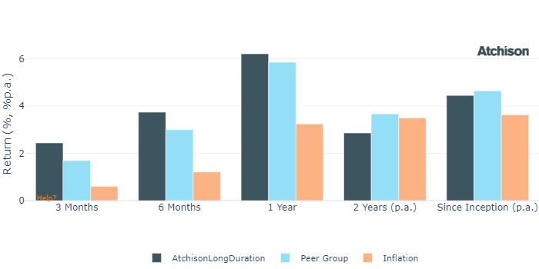

Cumulative Performance Since Inception

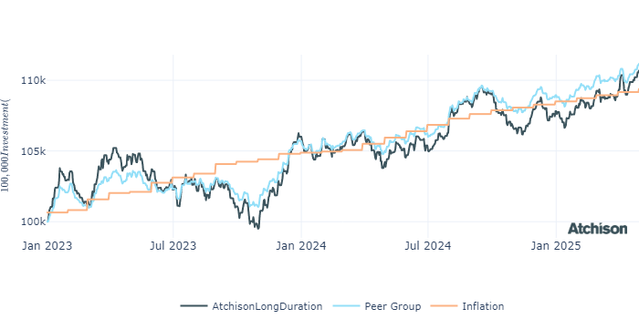

Portfolio Allocations

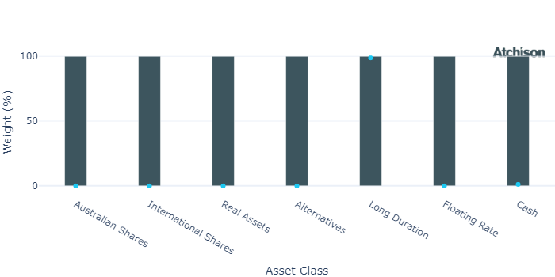

Portfolio Construction

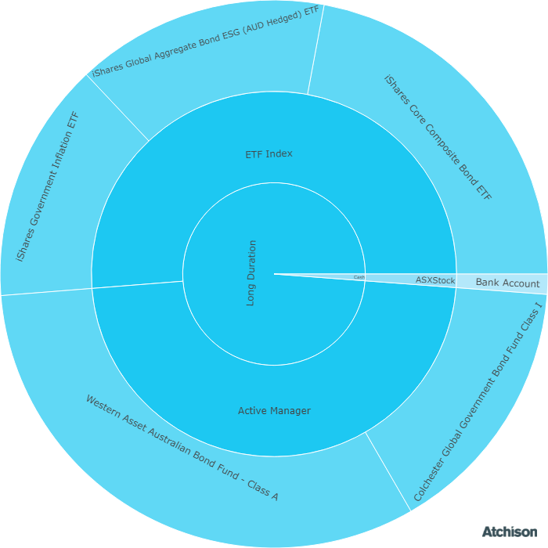

Correlations

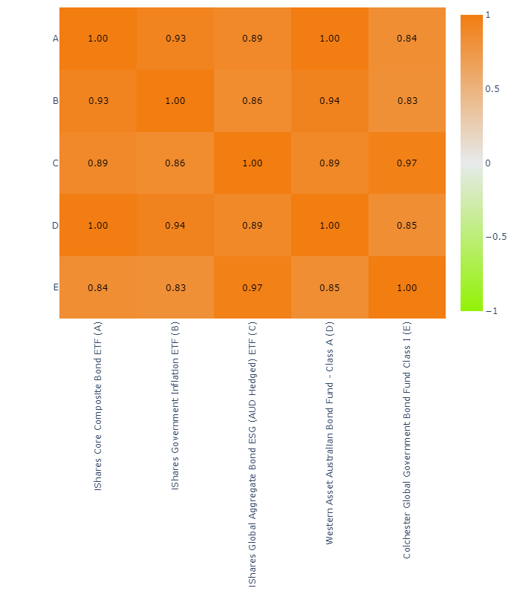

Underlying Manager Performance

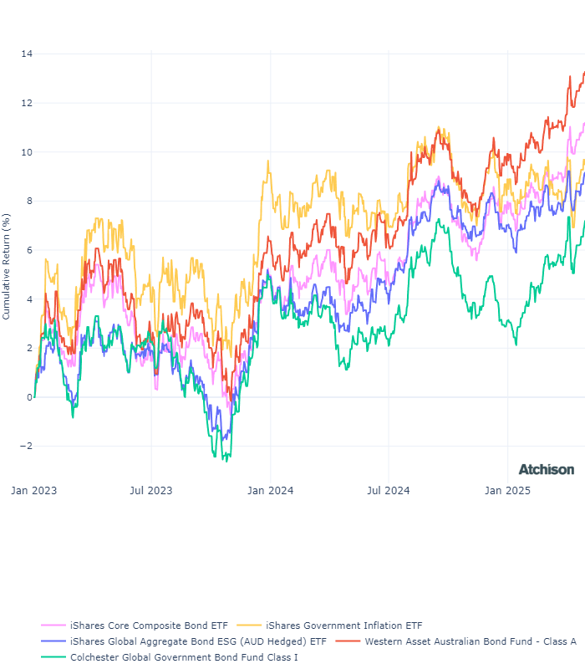

|  |  |  |
| --- | --- | --- |
| **Strategy** | **1 Year** | **2 Years (p.a.)** |
| iShares Aus Bond | 7.0 | 3.02 |
| iShares CPI Bond | 2.28 | 1.19 |
| iShares Globa Agg ESG | 6.32 | 3.12 |
| WA Aus Bond | 7.62 | 3.65 |
| Colchester Gov Bond | 5.9 | 2.36 |
| **BM: Duration** | **6.68** | **3.1** |
| Cash | 4.57 | 4.46 |

Inception Date: 31 December 2022

Underlying investment manager returns are shown after fees and before tax

Market Update

Australian share market recorded its first monthly gain since January returning 3.6% for the month of April and 9.8% for the 12 months. The Australia market followed the lead from the US share market on news of trade deals.  
  
Australia copped a 10% US tariff on our exports, however only 5% of Australian exports go to the US. The bigger threat to Australian exports comes from reduced exports to China and Asia.  
  
10 out of 11 sectors in the S&P/ASX 200 posted gains, led by Communication Services, Information Technology and Consumer Discretionary, each rising by 6%. Energy was the only sector to report a loss.  
  
China's manufacturing sector contracted in April, with the official PMI falling to 49.0, its lowest since December 2023, due to escalating U.S. tariffs and weakening export demand.  
  
Trump placed eye-watering 145% tariff on China but for most other nations a 90-day pause on reciprocal tariffs, leaving a 10% universal tariff in place.  
  
Global share markets plunged at the beginning of the month on worries about a full-blown trade war, The Trump Dump initially caused US shares to fall 17%, 16% globally and 10% in Australia. While gold surged to new highs.  
  
The Federal Open Market Committee (FOMC) left the Federal Funds Rate unchanged at the range of 4.25 – 4.50% at the March meeting and projected two rate cuts later this year.  
  
The RBA left interest rates on hold at 4.10%, but is expected to engage in another rate cut of 0.25% in May. Australia’s headline inflation (total inflation) remained steady in Q1 2025 at 2.4% annually, within the target band of 2 – 3%.   
  
Most fixed income indices advanced as rates declined on weaker economic growth expectations. The Australian Government 0+ index was among the best performers, rising by 2% for the month, with the index's yield falling to 4%.  
  
Gold maintained its winning streak in 2025, reaching historic peak of US$3,500 per ounce before experiencing volatility. A significant driver behind’s gold’s stellar performance has been the substantial decline in the US dollar.

Fine Print

Important Notice: This document is published by TAG Asset Consulting Group Pty Ltd, trading as Atchison Consultants, ABN 58 097 703 047, AFSL 230 846. Atchison Consultants distributes its investment solutions via platform and dealer groups (financial advisory groups).

Warning: Please be advised that past performance is not indicative of future performance. The returns discussed herein are based on model asset allocations and are for illustrative purposes only. Actual returns may differ due to variations in fees, timing of model change implementation, and the need to substitute individual holdings where reliable data was not available from our data providers. Any insights or recommendations provided in this document are intended for general advice purposes only and are based on our opinion of the investment merits of the financial products discussed, independent of the financial circumstances of any individual. Before proceeding with any investment based on the information provided, recipients must assess its suitability to their financial situation and consider seeking advice from an independent financial advisor.

Disclaimer: While care is taken to ensure the accuracy and completeness of the information presented herein, no warranties or representations are made as to its reliability. The content provided is derived from publicly available sources, or external data providers, which have not been independently verified by Atchison Consultants. Atchison Consultants, along with its directors, officers, employees, and agents, expressly disclaims any liability for errors, inaccuracies, or omissions in this document, as well as for any loss or damage that may arise from reliance on its contents. Readers are cautioned to verify all information independently before taking any actions based on this report.